Nurix & Unifi: AI Voice Agent for Recruiting

This document outlines the governance and compliance framework that Nurix will implement for its AI Recruiting Voice Agent, developed in partnership with Unifi. The solution is designed to support compliant, and transparent use of AI in recruitment workflows, with adherence to relevant state and federal regulations applicable to vendors and developers of automated employment decision tools.

Nurix Commitments
Nurix will take the following steps to ensure compliance and risk mitigation:

1. Technical Design & Fairness
- Implement the solution as described in Appendix A, including the use of a transparent and auditable matching algorithm for evaluating candidate responses to subjective questions.
- The matching logic will be informed by a phrase bank provided by Unifi, mapped and version-controlled by Nurix.
- Document the intended outputs, use cases, and logic behind AI decisions as part of a transparent system card.

2. Risk & Compliance Governance
- Maintain and routinely update a Risk Management Policy governing AI system deployment, as required for developers of employment-related automated tools.
- Conduct quarterly reviews of AI models, processes, and risk mitigations to remain compliant with evolving state-level regulations.
- Retain all production-level artifacts and changes (e.g., prompt templates, scoring logic, guardrails, model versions) for a minimum of four (4) years from the date of creation or deployment.
- Perform and document regular internal audits.
- Support any external audit initiated by Unifi or required by applicable law.

3. Change Notification & Legal Coordination
- Notify Unifi, as required by law or contract, for instance:
  - The purpose, benefits, and intended uses of the system.
  - The intended outputs and decisions produced by the system.
  - All mitigation strategies implemented to manage foreseeable risks of bias or harm.
  - The recommended guidelines for how the system should — and should not — be used, including human-in-the-loop requirements and safeguards.
4. Public Disclosures
Nurix will publish and maintain a public-facing statement on its website that includes:
- A description of the AI system Nurix offers for the Recruiting Voice Agent.
- The methods used to mitigate reasonably foreseeable risks of discrimination.
This statement will be reviewed and updated within 90 days of any material system change.
5. Discriminatory Effects or Risk Disclosure
If a discriminatory effect or material risk is discovered through audits or live operations:
- Nurix will notify Unifi and any applicable State agency within 90 days.
- The notification will include a summary of the issue, affected groups (if known), and the mitigation measures taken.

Roles & Responsibilities
- Nurix will be responsible for developing, updating, and maintaining the AI system in compliance with applicable vendor obligations under relevant State and Federal laws.
- Unifi will remain responsible for its own use of the system, human oversight processes, and any employer-side obligations required by law.

Operational Process
Nurix will follow a five-phase operational process to ensure safe, and compliant deployment of the AI Recruiting Voice Agent:

1. Design & Build
- Unifi provides phrase lists for subjective questions' evaluation.
- Nurix integrates these into matching logic, defines prompts, and prepares compliance documentation.

2. Pre-Deployment Testing
- Run simulations along with the Unifi team to validate matching logic and check for issues.
- Define fallback flows and human review conditions

3. Deployment & Monitoring
- Launch a controlled rollout with full transcript logging and real-time escalation triggers.
- Continuously monitor for anomalies and candidate experience issues.

4. Governance & Audits
- Conduct quarterly reviews and maintain 4-year change logs.
- Support internal and external audits with complete version history and documentation.

5. Communication
- Provide Unifi with regular reports and notifications.
- Maintain a public statement describing system use and safeguards, updated within 90 days of major changes.

Appendix A: Solution diagram and Call Logic

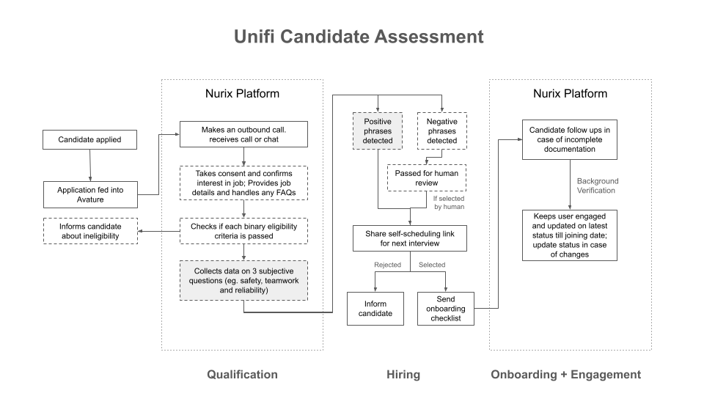

Screening and Multi-Call Logic
As part of the proposed AI-driven recruitment lifecycle, candidates may engage in multiple structured conversations throughout the hiring journey.
These touchpoints are designed to support screening, information capture, and reviewer enablement - without introducing AI-based judgment or bias into decision-making.

1. Screening (Deterministic, SOP-Based)
In the early stage, the AI Agent conducts structured screening based on Unifi’s defined SOP rules. For instance:
- If a candidate says, “I’m TSA-cleared” or “I can work overnight shifts,” these are recognized as qualifying indicators.
- If a candidate says, “I don’t have a driver’s license,” it is tagged as a disqualifier and the conversation may be ended after communicating the reason.
As the AI Agent absorbs information and takes only boolean or deterministic decisions in this process based on an SOP - there is no risk of bias

2. Subjective Questions (Structured Answer Collection)
For open-ended prompts such as, “What would you do when you see a coworker not following safety rules?”, the algorithm:
- Collects the candidate’s complete responses during the call.
- Tags each phrase against Unifi’s approved positive / negative phrase list using a semantic matching algorithm.
- Highlights positive phrases in green and negative ones in red for easy reviewer scanning.
- Sends candidates whose responses include positive phrases straight to self-scheduling for the next interview.
- Flags candidates whose responses include negative phrases for an asynchronous human review. If they pass the review, they will be sent to self-scheduling for the next interview.
The final determination for any candidate response with negative phrases is made by a human reviewer, with the matching algorithm only serving as a support tool for enabling the review.
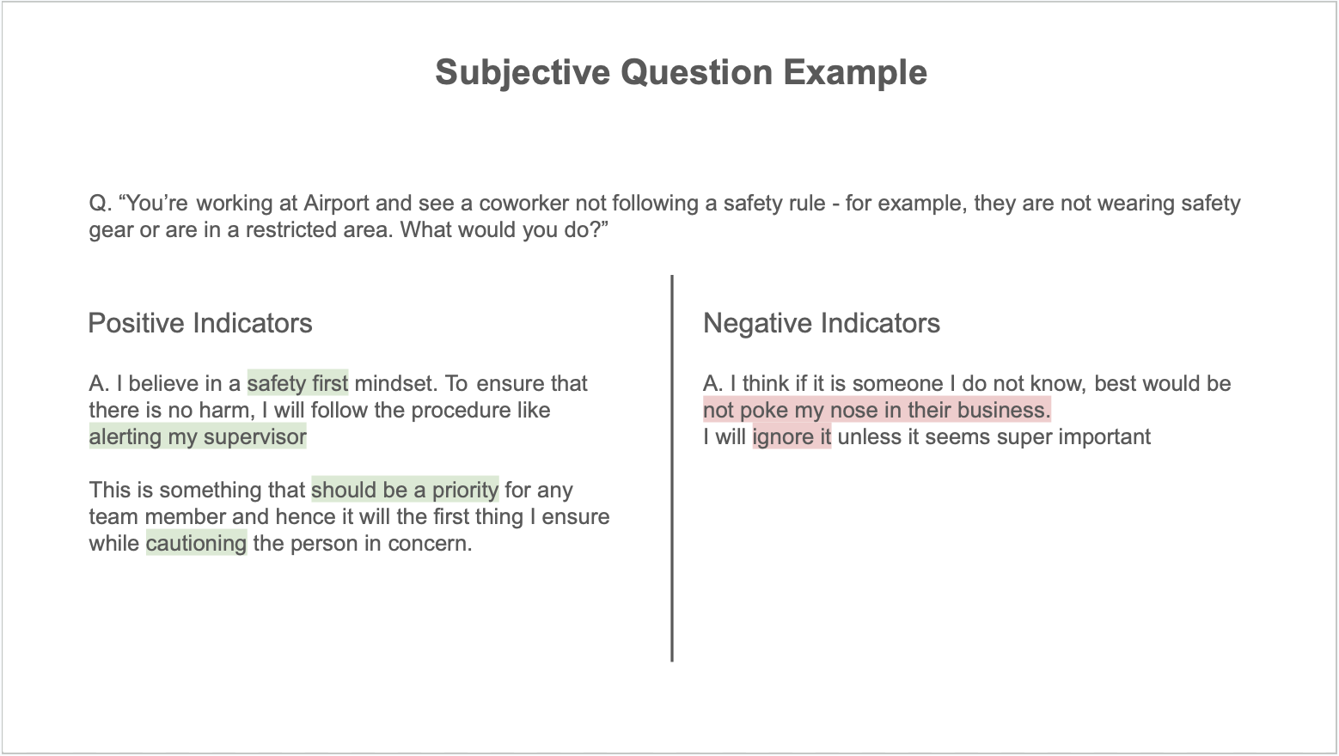

3. Ongoing Engagement (Post-Selection Follow-Up)
Once a candidate has been selected, the system continues to support post-offer engagement - such as onboarding guidance, pre-joining reminders, and document checklists through follow-up calls or chat-based interactions.
These conversations are structured but personalized, helping maintain candidate clarity and retention till the start date.
They involve no decision making and will share information to the ATS in case of any updates.

